Exercise 4: Creating and Configuring a Maven Project
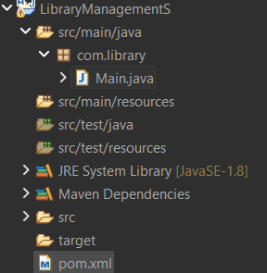
<project xmlns="http://maven.apache.org/POM/4.0.0"
xmlns:xsi="http://www.w3.org/2001/XMLSchema-instance"
xsi:schemaLocation="http://maven.apache.org/POM/4.0.0
https://maven.apache.org/xsd/maven-4.0.0.xsd">

<modelVersion>4.0.0</modelVersion>

<groupId>com.library</groupId>
<artifactId>LibraryManagementS</artifactId>
<version>1.0-SNAPSHOT</version>
<packaging>jar</packaging>

<properties>
<maven.compiler.source>1.8</maven.compiler.source>
<maven.compiler.target>1.8</maven.compiler.target>
<project.build.sourceEncoding>UTF-8</project.build.sourceEncoding>
<spring.version>5.3.9</spring.version>
</properties>

<dependencies>

<!-- Spring Context -->
<dependency>
<groupId>org.springframework</groupId>
<artifactId>spring-context</artifactId>
<version>${spring.version}</version>
</dependency>

<!-- Spring AOP -->
<dependency>
<groupId>org.springframework</groupId>
<artifactId>spring-aop</artifactId>
<version>${spring.version}</version>
</dependency>

<!-- Spring Web MVC -->
<dependency>
<groupId>org.springframework</groupId>
<artifactId>spring-webmvc</artifactId>
<version>${spring.version}</version>
</dependency>

</dependencies>

<build>
<plugins>

<!-- Maven Compiler Plugin -->
<plugin>
<groupId>org.apache.maven.plugins</groupId>
<artifactId>maven-compiler-plugin</artifactId>
<version>3.8.1</version>

<configuration>
<source>1.8</source>
<target>1.8</target>
</configuration>

</plugin>

</plugins>
</build>

</project>

package com.library;

public class Main {

public static void main(String[] args) {
System.out.println("LibraryManagementS Maven project configured successfully.");
}
}

